## Structure

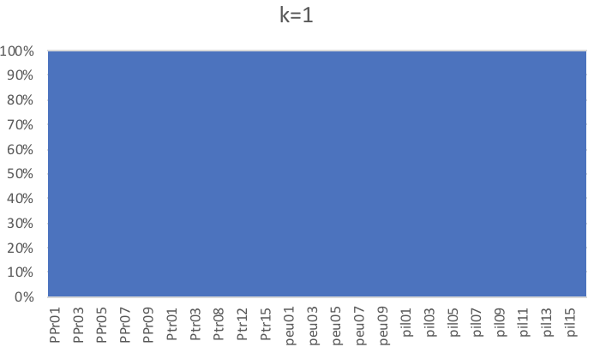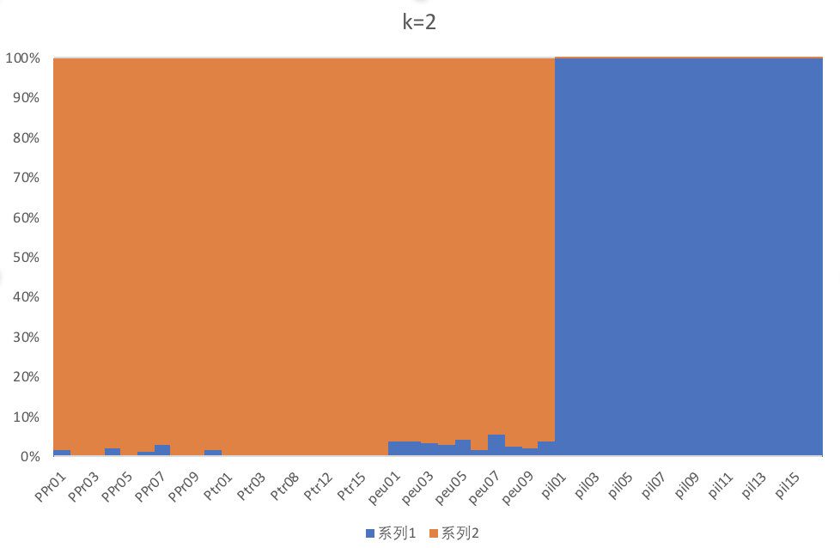

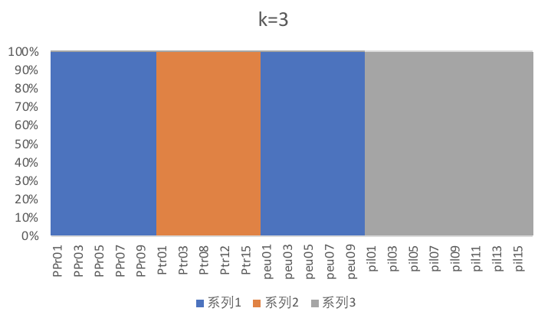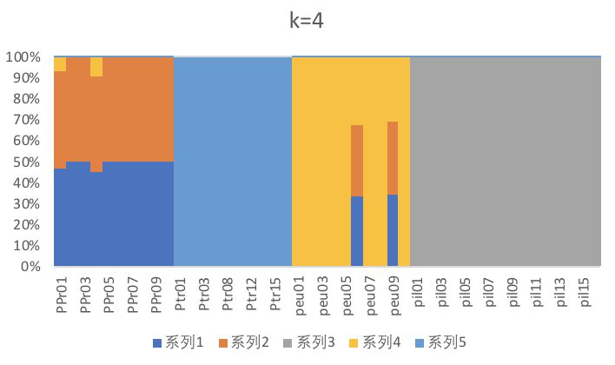

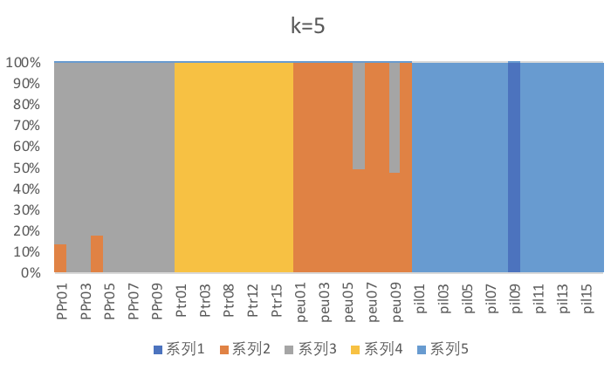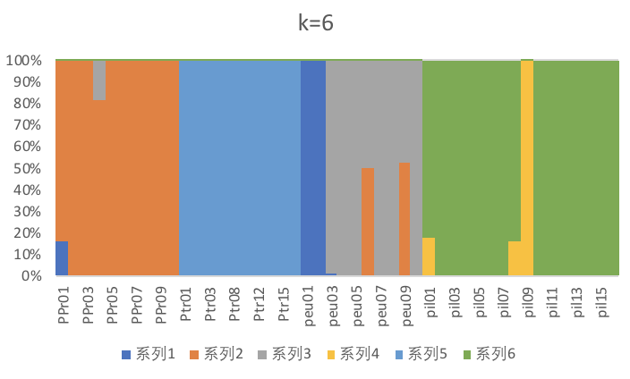

#cat *.log | grep CV

CV error (K=10): 0.38541

CV error (K=1): 0.99183

CV error (K=2): 0.51576

CV error (K=3): 0.22660

**CV error (K=4): 0.17662**

CV error (K=5): 0.20110

CV error (K=6): 0.22979

CV error (K=7): 0.24047

CV error (K=8): 0.32271

CV error (K=9): 0.28246

## PCA

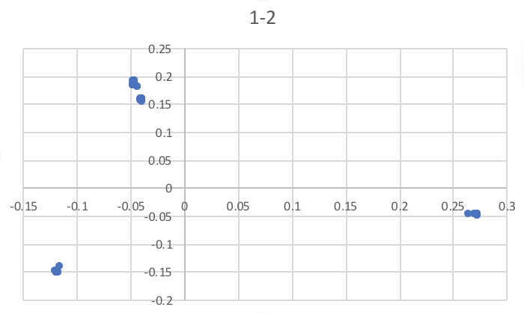

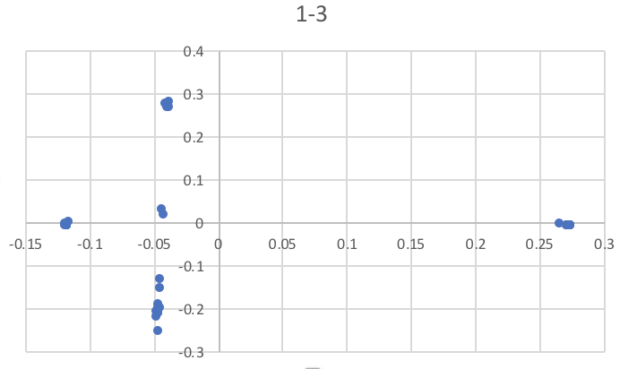

## NJ树

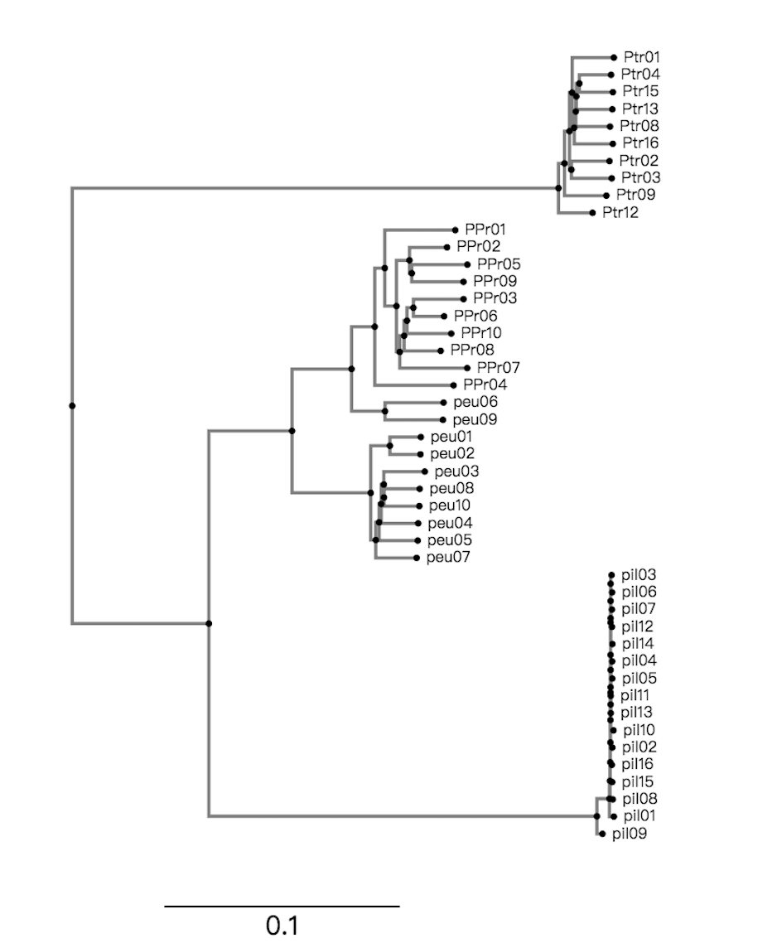

## 计算Fst

|  |  |  |  |  |
| --- | --- | --- | --- | --- |
|  | peu | ptr | ppr | pil |
| peu |  | 0.6276967074444509 | 0.32704103560426495 | 0.6486967853083726 |
| ptr |  |  | 0.6669426234749519 | 0.8395615693490903 |
| ppr |  |  |  | 0.6928670504434757 |
| pil |  |  |  |  |